Gallowtoun Park Boating Pond

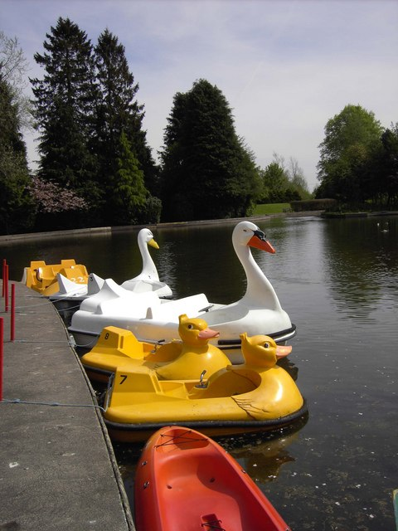

The client is the Gallowtoun Park Community Trust who manage the park and boating pond. Until now they have used an ad-hoc paper system for managing their employees, volunteers, sales and maintenance for the boating pond. However, as a condition of funding, Fife Council has told them they need to professionalise their system. They are requesting we design and, if the design is accepted, implement a computer system to manage their boating pond business. (The rest of the park is managed by a different part of the Trust; this system only applies to the boating pond.)

The boating pond has 17 boats, consisting of: 3 1-person kayaks, 2 4-person swan boats, 10 2-person duck boats and 2 2-person row boats. It has a boating shed in which the boats can be stored and where boat maintenance takes place. The boat shed also stores tools needed to maintain the boats, and also materials such as glue and plastic sheeting, also used for maintenance. The tools are kept in a locked cabinet for safety, only the head boatman has a key. The boats are brought out to the pond in the morning by the boat staff, and put back and checked at night. The pond is open from 10am to 6pm.

The boating pond also has a small boathouse with a reception area. Here staff hire out boats at the following prices per hour:
Kayak £6
Swan Boat £8
Duck Boat £5
Row Boat £12

This charge covers renting the boat and life jacket.

Rentals are recorded in writing in the rental book, and the money is kept in a cash box. Boats can be booked a week in advance for a one hour slot, these bookings are also written in the rental book. The staff member takes a note of the customer’s name and contact details in this book, when they book or rent a boat, for safety reasons and in case of theft or dispute. It is expected that in the new system this paper system will be replaced with a computerised system.

The boathouse has a rack of 40 life jackets. Each customer is issued with a life jacket when they rent a boat. There are 15 child-sized and 25 adult-sized life jackets.

The boat house also sells a small range of snacks and drinks. Sales are recorded in the book and money stored in the cash box.

The Community Trust employs a full-time manager who oversees all the boating pond activity. It employs one full-time head boatman, responsible for all boat maintenance. There are 2 volunteer boat-workers who help the head boatman with the boats. If a customer gets into problems with their boat, it would be the responsibility of the boatman or his team members to help them.

There is also one full-time customer service employee who is responsible for boat rentals, bookings, snack sales and managing stock in the boathouse. There are 2 part-time staff and one volunteer, also working in the boathouse, under the management of the customer service employee. Staff are salaried and paid monthly, volunteers are unpaid. All staff must be PVG checked as they may be in contact with vulnerable persons. All full-time staff must be trained in first aid.

